NISAW Sample Proclamation for Declaring National Invasive Species Awareness Week

February 26 – March 3, 2024

WHEREAS, invasive aquatic, riparian, and terrestrial species influence the productivity, value, and management of a broad range of land and water resources in (insert location here); and

WHEREAS, the costs to prevent, monitor, and control invasive species combined with the costs to crop damage, fisheries, forests, and other resources cost the U.S. $120 billion annually; and

WHEREAS, after habitat destruction, invasive species are the second greatest threat to biodiversity; and

WHEREAS, invasive species threaten the survival of native plants and animals, and interfere with ecosystem functions by changing processes such as fire, nutrient flow, and flooding; and

WHEREAS, invasive species are a significant threat to almost half of all native species currently listed as federally endangered; and

WHEREAS, invasive species impair infrastructure and impede transportation, water delivery systems, and energy production; and

WHEREAS, invasive species impede industry, threaten agriculture, obstruct outdoor recreation, endanger human health, and are becoming increasingly harder to control as a result of rapid global commercialization and human travel.

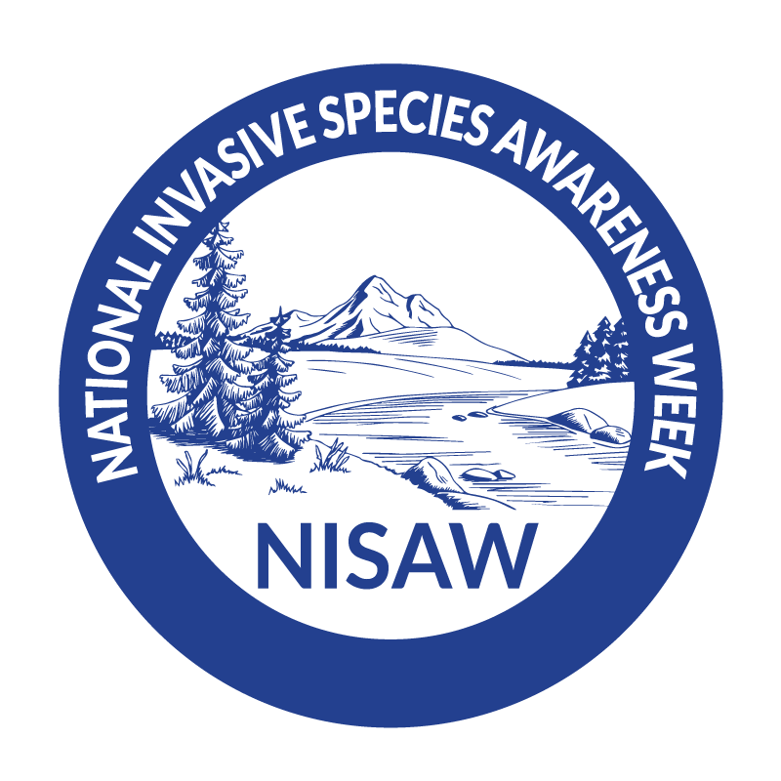
NOW THEREFORE, BE IT PROCLAIMED BY THE __________________ that February 26 – March 3, 2024, is declared to be National Invasive Species Awareness Week and hereby encourage residents to participate in National Invasive Species Awareness Week to promote knowledge and understanding of the threats posed by invasive species.

SIGNED:

ATTEST:

