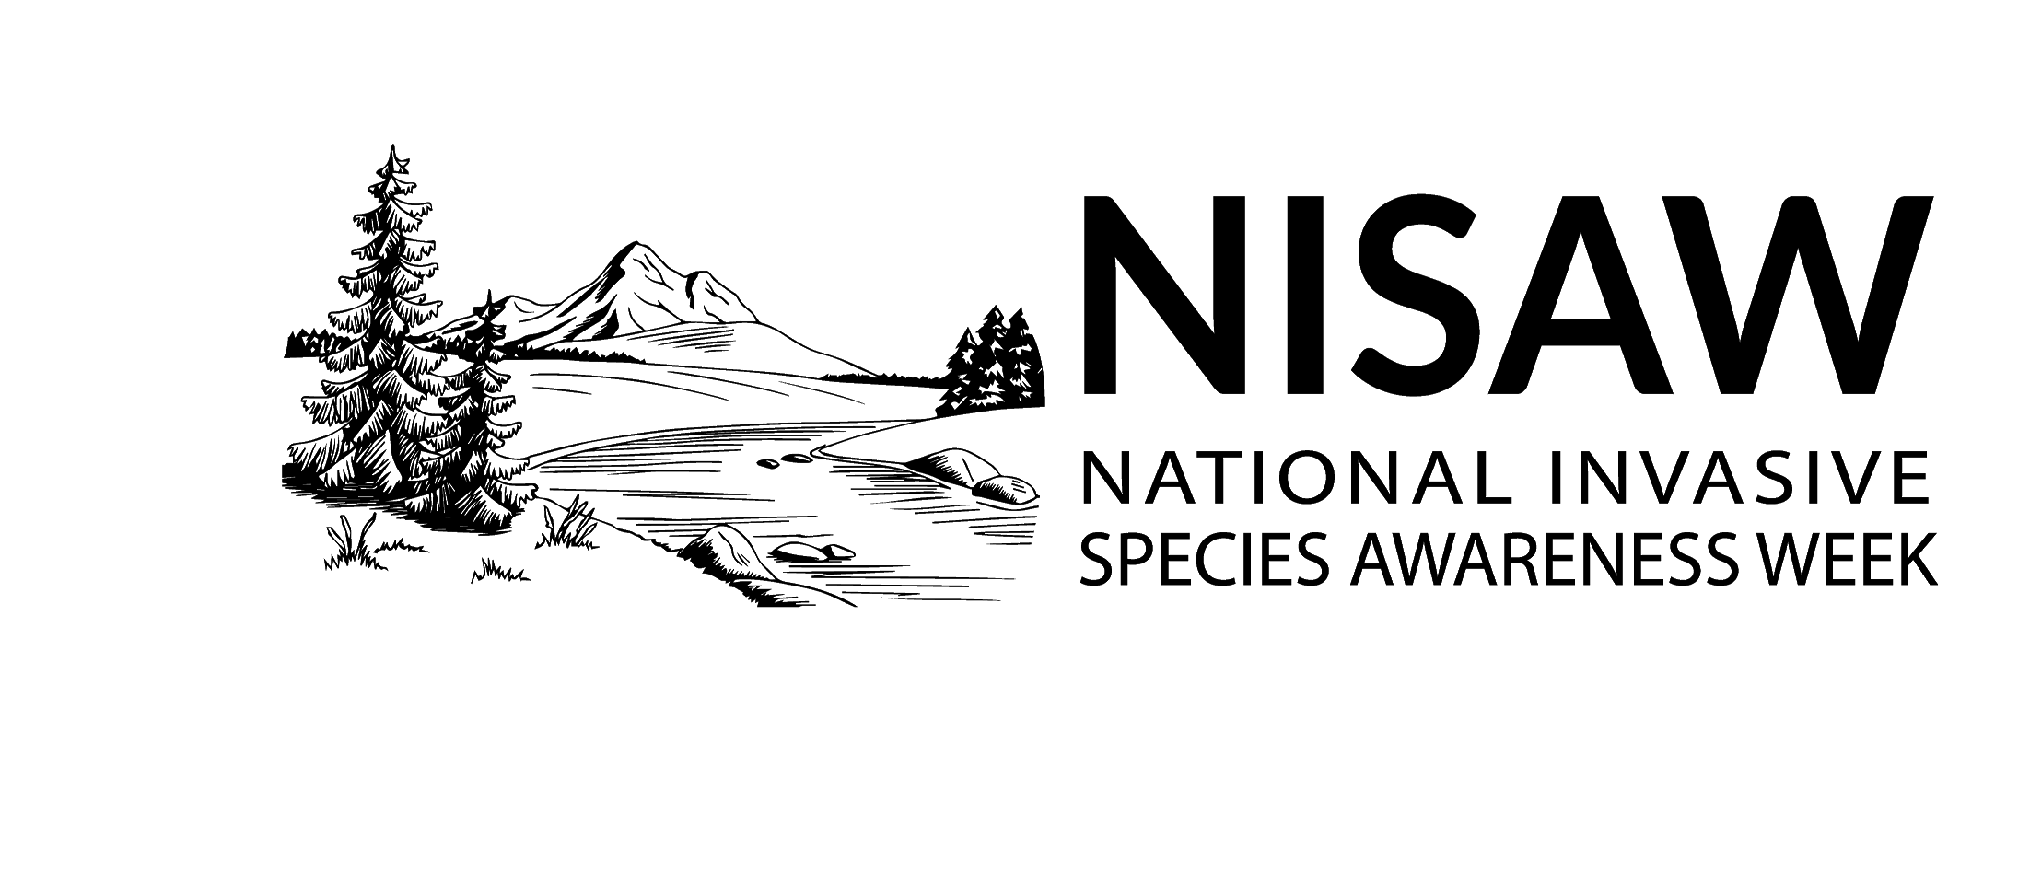

National Invasive Species Awareness Week 2023

Sample Social Media Posts
Your voice can help protect our natural spaces from #InvasiveSpecies during #NISAW. Find an event near you at https://www.nisaw.org/

The annual U.S. cost from #InvasiveSpecies is $120 billion, with a minimum of 100 million acres being affected (i.e. the size of California). Learn more about how you can advocate for their management this #NISAW at https://www.nisaw.org/

🚤 Zebra and quagga mussels have cost more than other #InvasiveSpecies, costing an estimated $6 billion in prevention and control efforts since their arrival in 1988. #NISAW

💵 The potential estimated costs of a quagga mussel introduction into the Pacific Northwest is more than $500 million annually, including costs to control mussels at irrigation, hydropower, and municipal drinking water facilities. #NISAW #InvasiveSpecies #PNW

Lake Tahoe, the second deepest lake in the U.S., has estimated an impact of more than $20 million annually if zebra or quagga mussels invade. #InvasiveSpecies #AIS #NISAW

💵 The annual losses to the Great Lakes Region, because of ship-borne #InvasiveSpecies, is at least $200 million. Learn more about what you can do this #NISAW to stop the spread at http://stopaquatichitchhikers.org/prevention/#clean-drain-dry @CleanDrainDry

#SpottedLanternfly feeds on a wide range of fruit, ornamental and woody trees. If allowed, this pest could seriously impact the country’s 🍇 grape, 🍊 orchard, and 🌳 logging industries. Find out what you can do to stop this #InvasiveSpecies #NISAW https://www.aphis.usda.gov/aphis/resources/pests-diseases/hungry-pests/slf/spotted-lanternfly

Densities of invasive carps 🐟 in parts of the Mississippi River basin are thought to be among the highest in the world. Like all #InvasiveSpecies, if left uncontrolled, they can and will limit water use now and into the future. #NISAW

Cheatgrass grows furiously in spring and dies in early summer, leaving dry tinder. 🔥 The Great Basin now has the nation's highest wildfire risk, and rangeland fires are outpacing forest fires when it comes to acreage destroyed. #NISAW #InvasiveSpecies

In FY 2020, the Department of Interior estimated it spent $143 million to manage invasive species for 400+ million acres of public lands. That’s roughly 35 cents per acre for all #InvasiveSpecies research, prevention, EDRR, management and restoration. #NISAW

