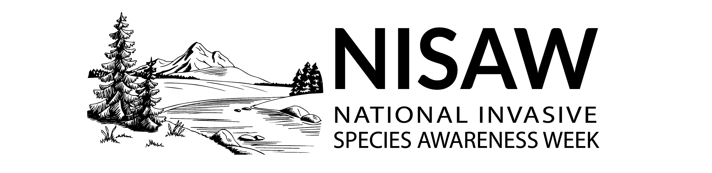

NISAW 101: National Invasive Species Awareness Week 2022

National Invasive Species Awareness Week (NISAW) is an international event to raise awareness about invasive species, the threat that they pose, and what can be done to prevent their spread. Representatives from local, state, federal, and regional organizations discuss legislation, policies, funding, and improvements that can be made to prevent and manage invasive species.

From February 28 - March 4, 2022, invasive species experts will come together in Washington, D.C. to inform and educate officials about prevention and management priorities. Partners around the country host local events to advocate to elected officials, decision makers, and the public on how they can help to stop the spread of invasive species and protect our precious resources. Sponsorship opportunities are available.

NISAW is managed by the North American Invasive Species Management Association (NAISMA).

We hope you make NISAW your own. Nobody knows your community’s invasive species challenges and potential solutions like you do. Share your success with the hashtags #NISAW and #InvasiveSpecies and tag us @InvasiveSpeciesWeek on Facebook and communicate your priorities to your elected officials.

Why should elected officials care about invasive species?
Invasive species impact everyone. When not monitored or controlled, invasive species can cause harm to our economy, environment or human health. The term "invasive" is used for aggressive species that grow and reproduce rapidly, displace native species, and cause major disturbance to the areas in which they are present.
Invasive species, if left uncontrolled, can and will limit land and water use now and into the future.
The longer we ignore the problem the harder and more expensive the battle for control will become.
Thankfully, there are solutions. By learning about invasive species and participating in events across the nation, elected officials and the general public can work together to solve invasive species issues at local, state, tribal, regional, international and national scales.
Through education, Information, and advocacy, we can help to stop the spread of invasive species in the nation’s lands, waterways, and everything in between, we can create positive outcomes in habitats. Every year NISAW aims to protect natural ecosystems from invasive species for the benefit of everyone.

How can organizations and agencies participate?
Organizations and individuals are encouraged to join together in projects, events and activities that promote stopping the spread of invasive species.
To you, invasive species managers, we salute you — and humbly offer these 5 suggestions of things individuals, organizations, or agencies can do to participate in NISAW. Remember to use the hashtags #NISAW and #InvasiveSpecies in your publicity so we can connect and celebrate our achievements together!

- Share the NISAW Webinar Series and resources with their networks. https://www.nisaw.org/
- Learn about invasive species, especially those found in your region. Share what you know on social media (use the NISAW social media images to get started).
- Ask your senators and representatives at the state, local and national level to support invasive species prevention and management efforts.
- Prevent invasive species when recreating in the outdoors. Visit PlayCleanGo.org for more information.
- Publicize your invasive species event on the NISAW event calendar.

Remember: Use the hashtags #NISAW and #InvasiveSpecies
in your publicity during February 28 – March 4, 2022.

Campaign contact:
Elizabeth Brown
Program Manager, North American Invasive Species Management Association
ebrown@naisma.org

