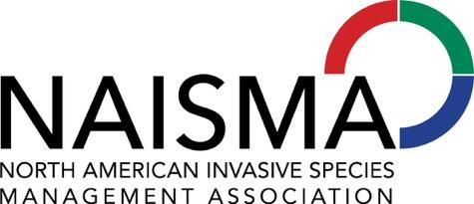
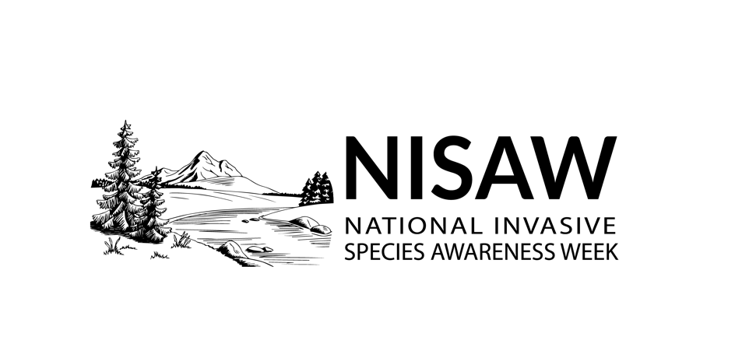
Contact: Elizabeth Brown, Program Manager, North American Invasive Species Management Association, ebrown@naisma.org
FOR IMMEDIATE RELEASE
Help Stop Invasive Species: National Invasive Species Awareness Week Encourages Information and Advocacy — February 22-26, 2021
Do your part to engage the public and elected officials about protecting natural habitats by slowing the spread of invasive species.
MILWAUKEE, WI – With new administrations and representatives at the state and national levels comes a renewed effort to educate decisionmakers on the long-term ecological devastation and cost of invasive species.
National Invasive Species Awareness Week (NISAW) is an annual international event to raise awareness about invasive species, the threat that they pose, and what can be done to prevent their spread. Representatives from local, state, federal, and regional organizations discuss legislation, policies, and improvements that can be made to prevent and manage invasive species. A series of virtual webinars are planned online from February 22-26, 2021, and sponsorship opportunities are available.
“Invasive species are a continent-wide problem that starts at home,” said Belle Bergner, director of the North American Invasive Species Management Association. “The good news is that everyone can be part of the solution. Communities across North America would benefit from increased funding and management options for invasive species to protect our precious land and water.”
NISAW gathers outdoor enthusiasts, land managers and elected officials to showcase their invasive species efforts and inspire others to address invasive species through management and prevention.
“Everyone can do something to prevent invasive species from taking over agricultural and natural environments, and we encourage organizations and individuals to take leadership teaching their community about how to solve invasive species issues locally,” Bergner says.
During NISAW Part II—May 15-22—partners may host local events to remove invasives and educate elected officials, decision makers, and the public on how they can help to stop the spread of invasive species and protect communities.
NISAW invites organizations and individuals to use and share the campaign materials, which can be found at https://www.nisaw.org/nisaw-toolkit/. Materials include social media posts and graphics, templates for a press release and radio PSA, and more.
# # #
The North American Invasive Species Management Association’s mission is to support, promote, and empower invasive species prevention and management in North America. Since 1993, NAISMA has been growing programs that bridge jurisdictional and geographic divides. In addition to organizing a variety of professional development opportunities, housing the Certified Weed Free Products program, and operating the PlayCleanGo® program, NAISMA is the lead partner on NISAW. Learn more at naisma.org.

