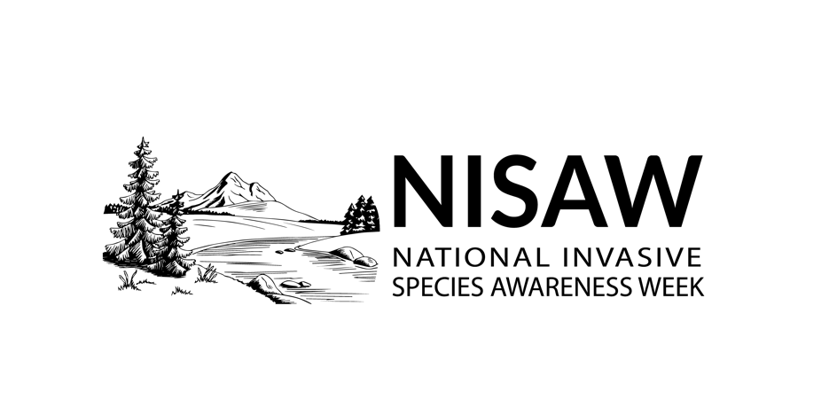 | INSERT YOUR LOGO OR LETTERHEAD

Contact: Your Name, Title, Phone Number, Email Address
FOR IMMEDIATE RELEASE
Help Stop Invasive Species: [Your local organization] [hosts/encourages/etc.] [your event or call to action] during National Invasive Species Awareness Week — May 15-22, 2021
Your local City, State – With new administrations and representatives at the state and national levels comes a renewed effort to educate decisionmakers on the long-term ecological devastation and cost of invasive species.
On [date + time], [your local organization name] is [hosting/encouraging/etc.] people to [do a particular invasive species engagement activity.]
An international event, the annual National Invasive Species Awareness Week seeks to raise awareness about invasive species, the threat that they pose, and what can be done to prevent their spread. Representatives from local, state, federal, and regional organizations discuss legislation, policies, and improvements that can be made to prevent and manage invasive species.
The term "invasive" is used for aggressive species that grow and reproduce rapidly, displace native species, and cause major disturbance to the areas in which they are present. Local environmental organizations are concerned the most with [list species of local concern and highlight their impacts on the natural landscape.]
A nationwide event May 15 through 22, NISAW encourages local organizers to raise awareness of the threat of invasive species and what people can do to prevent their spread.
“Invasive species are a continent-wide problem that starts at home,” said Belle Bergner, director of the North American Invasive Species Management Association. “The good news is that solutions start with everyone looking out their windows from home at what is on your property. If you are able to get to your local park, lake, or river, go with clean shoes and gear. Find a local event to learn how our invasive species managers and nonprofit organization leaders work hard making sure our lands and waters are friendly to native species of North America.”
“Everyone can do something to prevent invasive species from taking over agricultural and natural environments, and we encourage organizations and individuals to take leadership teaching their community about how to solve invasive species issues locally,” Bergner says. For instance, [what’s a good way everyday local people can help with local invasive species in this time?]
[You can add any level of detail you’d like to the end of this article. It’s a good idea to include quotes from major organizers and people making presentations.]
# # #
[Add some basic information about your organization or agency here, including a URL for your website, if applicable.]

The North American Invasive Species Management Association’s mission is to support, promote, and empower invasive species prevention and management in North America. Since 1993, NAISMA has been growing programs that bridge jurisdictional and geographic divides. In addition to organizing a variety of professional development opportunities, housing the Certified Weed Free Products program, and operating the PlayCleanGo® program, NAISMA is the lead partner on NISAW. Learn more at naisma.org.

