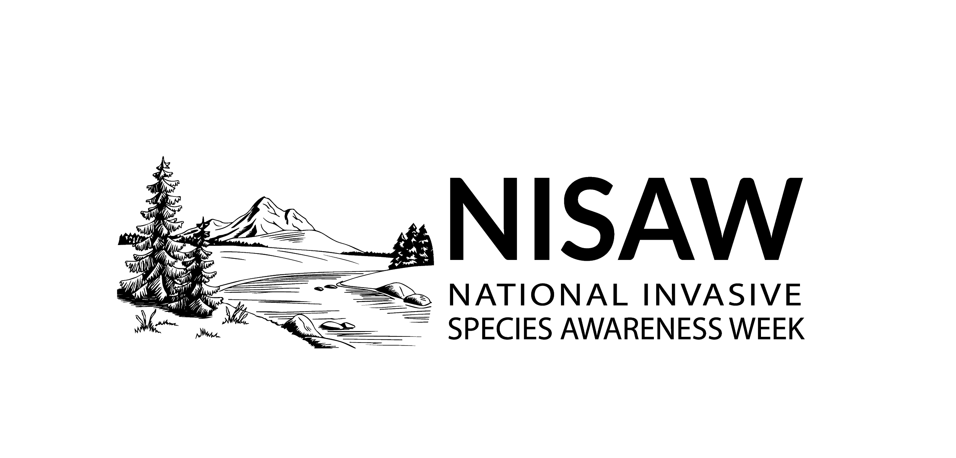

NISAW Public Service Announcement Templates

You can provide a copy of this public service announcement to your local radio or television news outlet. Many outlets support nonprofits by reading the PSA on-air free of charge, or they might request a follow-up interview with you or another member of your organization. If your station charges for air time, try seeking a sponsor to cover the cost.

For promoting events your local organization has planned:

“Our friends at [your organization name] need YOU to help slow the spread of invasive species during National Invasive Species Awareness Week.

Learn about [name two local invasive species], and [come to this volunteer event?] at [where, when], open to [who's it for?].

[Add a little history here, such as: For the past X years, [org name], based in [city, if locality is relevant], has engaged more than [x] volunteers to [what's your mission?], [accomplishing this impressive goal].

You can help them stop the spread of invasive species by visiting [organization website URL] to learn about volunteer events or make a donation.”*

*Instruction to NISAW participant: If your organization does not have a website, or you want to offer a more generalized message, you may replace the last sentence with “Help them stop the spread of invasive species by following the easy guidelines at PlayCleanGo.org.”

For sharing a general NISAW message:

“‘Slow the spread’ is an unexpected catchphrase of this spring. Due to the global coronavirus pandemic, we are all learning what invasive species managers have been doing for years. The 10th annual National Invasive Species Awareness Week seeks to slow the spread of invasive plants, animals, pests, fungi and other organisms in land and water.

The term "invasive" is used for aggressive species that grow and reproduce rapidly, displace native species, and cause major disturbance to the areas in which they are present. The good news is that solutions start at home.

By taking some basic care, you can greatly reduce the risk of spreading invasive species to the places that you love. Here’s how*:

*Instruction to NISAW participant: Choose the top 3 bullet points that make sense for your local community.

- Clean hiking boots, waders, boats and trailers, off-road vehicles and other gear in between outings.
- Avoid dumping aquariums or live bait into waterways.
- Clean your fishing equipment and don’t dump live bait.
- Buy firewood where you’ll burn it, or gather on site when permitted.
- Buy forage, hay, mulch and soil that are certified as “weed free.”
- Take extra care when traveling, gardening or moving recently killed plant material. Buy your plants from a reputable source and plant native species to support your local ecosystem. Avoid using invasive plant species at all costs.
- Volunteer to help remove invasive species from public lands and natural areas.
- Ask your political representatives at the state, local and national level to support invasive species control efforts.

